Carbohydrates Reading

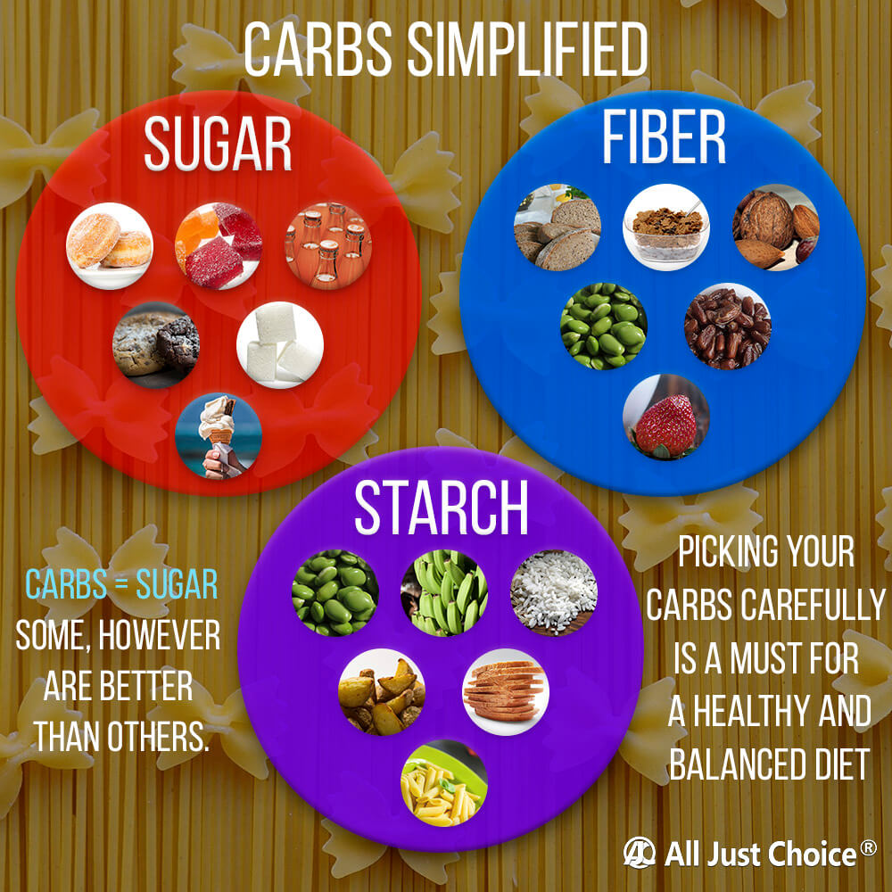
Carbohydrates (carbs) are a macronutrient naturally found in food. They come in three types: sugar, starch, and fiber. You might’ve heard that carbs are bad for you, but they’re an essential part of a healthy diet. They provide most of the energy your body needs to function properly.
Carbohydrates can be either simple or complex. Simple carbs are both sugars and some forms of starch, such as white rice. Your body breaks them down more quickly than complex carbs. This means that they’re a good source of quick energy. However, eating too many simple carbs can negatively impact your health because they cause blood sugar to spike quickly.
Complex carbs include some forms of starch and fiber. These have long chains of simple carbs that get broken down by your body before being digested. This means they provide energy for the body more slowly than simple carbs, but they also provide energy for a longer time period. Complex carbs are also less likely than simple carbs to be converted into fat. They don’t raise blood sugar levels as much.
When carbs are digested, they’re turned into glucose. Glucose is the main source of energy for your body. Simple carbs can provide a quick burst of energy, but complex carbs will provide energy for your body for a longer period of time because they release the sugar into your bloodstream more slowly.

Benefits
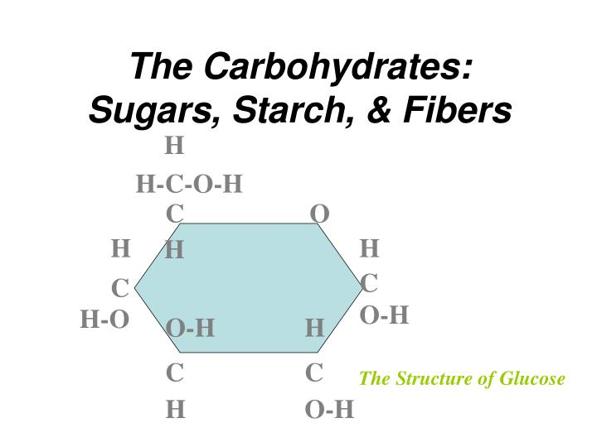
While the glucose from carbs is essential for everything in your body to function, it’s particularly important for brain function. Your brain uses 20 percent of your body’s energy. That’s more than any other organ. Here are more fun facts about the brain.
Eating too many simple or processed carbs can have negative effects on your cardiovascular health, but other carbs can actually reduce your risk of disease. Complex carbs, especially fiber, are associated with lower cholesterol levels. They’re also associated with a lower risk of diabetes because they don’t lead to blood sugar spikes. Eating carbs in the form of fiber can help improve the health of your digestive system. Fiber eases constipation by making your stool easier to pass.

Negative Effects
The brain and central nervous system rely on glucose for their primary source of energy. Without adequate carb intake and glucose levels, you might begin to feel tired, dizzy and weak. Athletes need adequate amounts of carbs prior to a competition for optimal physical and mental results. Another problem associated with over-consumption of carbohydrates is a decrease in cognitive functioning -- often experienced as "brain fog." This phenomenon is related to falling blood sugar levels, which is an almost inevitable consequence of overeating carbohydrates after the initial insulin spike
Eating carbohydrates in excess, particularly refined carbohydrates, can create a series of blood sugar highs and lows. Eat a large slice of cake with frosting, and your insulin levels are likely to rise significantly, paving the way for fat storage. Insulin rises because your body is working to decrease your blood sugar, which requires this hormone. Once the insulin triggered by carbohydrates takes the sugar out of your blood stream, you risk experiencing hypoglycemia, or low blood sugar. These swings in blood sugar wreak havoc on the bodies systems, including the cardiovascular system

Sources
There are many good carbs to choose from, but here’s a short list of foods that are good sources of carbohydrates:
- oatmeal (not instant or presweetened)  - whole wheat bread  - sweet potatoes  - brown rice  - Bananas  - black beans  - lentils  - apples  - chickpeas  - vegetables | 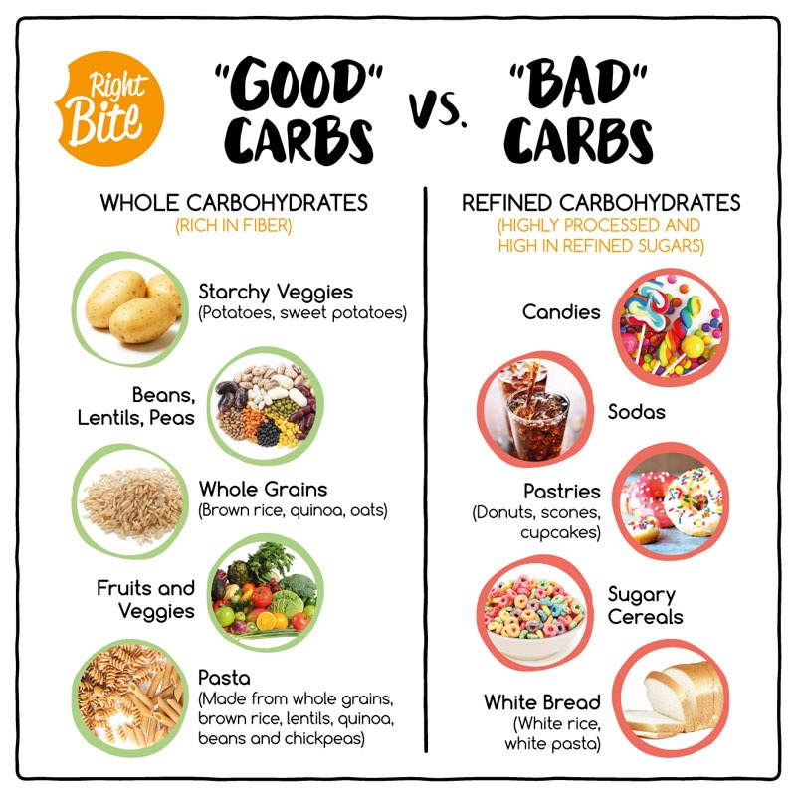

Proteins
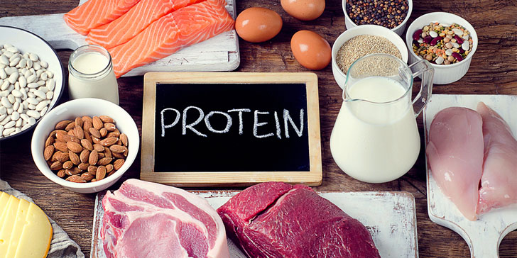
Protein are an important component of every cell in the body. Hair and nails are mostly made of protein. Your body uses protein to build and repair tissues. You also use protein to make enzymes, hormones, and other body chemicals. Protein is an important building block of bones, muscles, cartilage, skin, and blood.
Along with fat and carbohydrates, protein is a "macronutrient," meaning that the body needs relatively large amounts of it. Vitamins and minerals, which are needed in only small quantities, are called "micronutrients." But unlike fat and carbohydrates, the body does not store protein, and therefore has no reservoir to draw on when it needs a new supply.
Benefits of Proteins
One of the consequences of aging is that your muscles gradually weaken. The most severe cases are referred to as age-related sarcopenia, which is one of the main causes of frailty, bone fractures, and reduced quality of life among older adults. Eating more protein is one of the best ways to reduce age-related muscle deterioration and prevent sarcopenia. Protein can help your body repair after it has been injured. This makes perfect sense, as it forms the main building blocks of your tissues and organs. Numerous studies demonstrate that eating more protein after injury can help speed up recovery.
Negative effects of protein
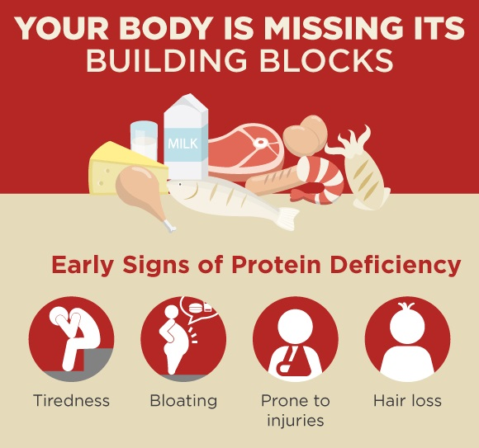
Muscle Wasting – Protein is , strength, and repair. Insufficient protein in your diet reduces lean body mass, muscle strength, and function. Not consuming enough protein can also cause muscle cramping, weakness, and soreness. Your body will take protein from muscle tissue and use it as energy to support other vital body functions when protein is low. This eventually causes muscle wasting or atrophy as a direct result of chronic, low dietary protein. essential for muscle growth, strength, and repair. Insufficient protein in your diet reduces lean body mass, muscle strength, and function. Not consuming enough protein can also cause muscle cramping, weakness, and soreness. Your body will take protein from muscle tissue and use it as energy to support other vital body functions when protein is low. This eventually causes muscle wasting or atrophy as a direct result of chronic, low dietary protein.
Poor Wound Healing – Wound healing is dependent on good nutrition, including protein intake. Protein deficiency has shown to contribute to low wound healing rates and reduced collagen formation, according to research. Without adequate protein, the wound healing process is said to be greatly compromised.
Infections – Your immune system functions best with adequate protein intake. Protein deficiency is indicated to impair your immune system. Without a healthy immune system, your risk of infection is increased and the ability to fight off infection is decreased.
Sources of Protein

Seafood (fish, shrimp, crab, etc)

White-Meat Poultry

Milk, Cheese, and Yogurt

Eggs

Lipids Reading
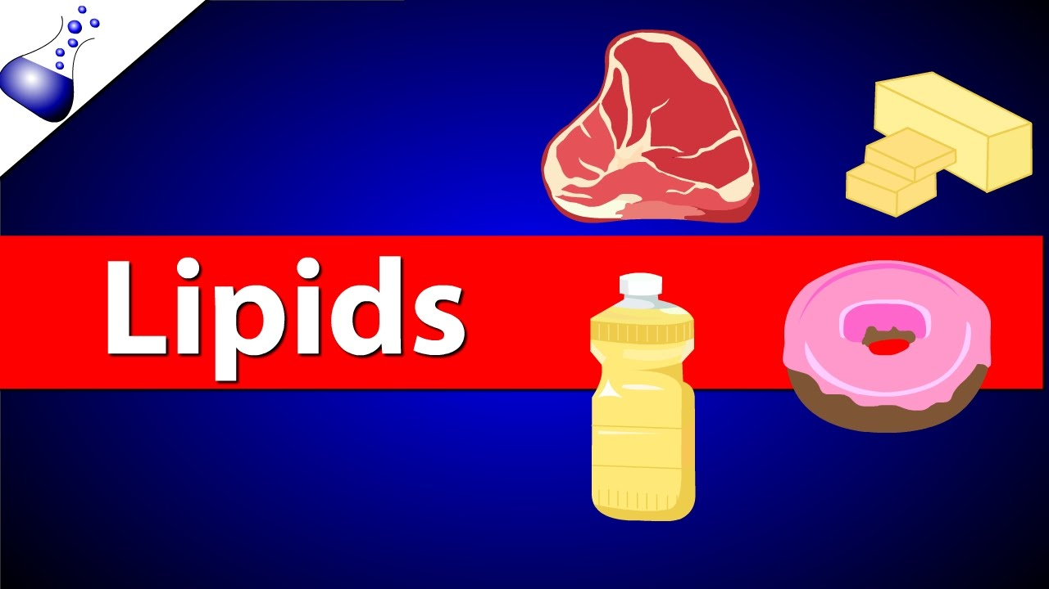
When it comes to diet, fats get a bad rap. Some of this is justified, because certain types of fat — and the fat-like substance cholesterol — may play a role in cardiovascular disease, diabetes, cancer, and obesity. But not all fats are created equal. Some fats are better for you than others, and may even help to promote good health. Knowing the difference can help you determine which fats to avoid, and which to eat in moderation.
Triglycerides, cholesterol and other essential fatty acids--the scientific term for fats the body can't make on its own--store energy, insulate us and protect our vital organs. They act as messengers, helping proteins do their jobs. They also start chemical reactions involved in growth, immune function, reproduction and other aspects of basic metabolism.
The cycle of making, breaking, storing and mobilizing fats is at the core of how humans and all animals regulate their energy. An imbalance in any step can result in disease, including heart disease and diabetes. For instance, having too many triglycerides in our bloodstream raises our risk of clogged arteries, which can lead to heart attack and stroke.

Benefits of lipids

Hormone Production

Cholesterol is a type of lipid needed to produce important steroid hormones in your body. Estrogen, testosterone, progesterone and the active form of vitamin D are all formed from cholesterol and are needed to maintain pregnancy, develop sex characteristics and regulate calcium levels in your body. According to the American Heart Association, about 25 percent of the cholesterol in your blood comes from your diet, from animal foods such as egg yolks, cheese and shrimp, and the other 75 percent is formed in your liver and cells.

Energy Production and Storage

The primary role of lipids in your body is to provide energy for muscles and body processes. Fat is energy dense, containing 9 calories per gram, whereas protein and carbohydrate contain only 4 calories per gram. About half of the fuel your body needs when at rest or during everyday activity comes from lipids. If you consume more calories than you need in a day, the excess energy is stored as lipids in adipose cells. In between meals and during exercise your body relies on these fats stores to provide energy. When we need extra energy--for instance, when we exercise--our bodies use enzymes called lipases to break down the stored triglycerides. The cell's power plants, mitochondria, can then create more of the body's main energy source: adenosine triphosphate, or ATP.

Negative effects of lipids
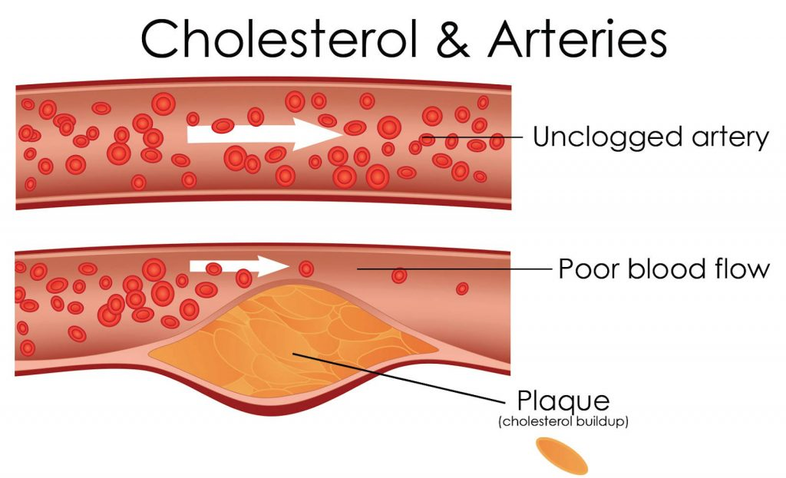
Eating foods that contain saturated fats raises the level of cholesterol in your blood. High levels of LDL cholesterol in your blood increase your risk of heart disease and stroke. The American Heart Association recommends limiting saturated fats – which are found in butter, cheese, red meat and other animal-based foods. Decades of sound science has proven it can raise your “bad” cholesterol and put you at higher risk for heart disease.
Fats in diet play a role in chronic diseases. Up to 70% of all cancers in the United States are attributable to diet for example. Around half of the population according to the USDA develops a diet-related chronic disease responsible for the leading causes of death like heart disease, cancer, stroke, diabetes, and arteriosclerosis. This raises the annual health costs to $250 billion in the USA. High fat, especially trans fats and unsaturated fats lead to heart disease, degenerative and inﬂammatory arthritis, osteoporosis, obesity, cancer etc.

Saturated fats | Unsaturated fats
Examples of foods with saturated fat are:  - fatty beef,  - lamb,  - pork,  - poultry with skin,  - beef fat (tallow),  - lard and cream,  - butter,  - cheese and  - other dairy products made from whole or reduced-fat (2 percent) milk. | Examples of foods with unsaturated fats are:  - Vegetable oil  - Avocado oil  - Peanut oil  - Avocados  - Olives  - Peanut butter | 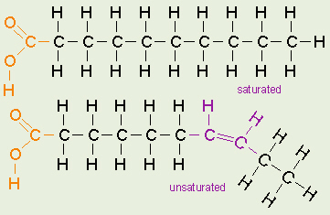
In addition, many baked goods and fried foods can contain high levels of saturated fats. Some plant-based oils, such as palm oil, palm kernel oil and coconut oil, also contain primarily saturated fats, but do not contain cholesterol.

Nutritionist Scenarios

Richard
Richard is 45 years old and is looking to change his diet in order to better his health for his future. He wants to live much longer and healthier for his future grandkids. Richard recently went to the doctor because lately he is feeling very low on energy and is forgetting a lot of things. He explained to his doctor that he has noticed he is thinking more slowly and is experiencing a brain fog. The doctor took samples from Richard and stated he has low blood sugar and is pre-diabetic. This is why Richard is seeking help from a nutritionist in order to change his diet to improve his energy levels, brain function and keep track of his blood sugar so that he will not become diabetic.
- What macromolecule do you think is effecting Richard and how?
- Second, what changes in diet would you recommend to Richard and why?

Tylin
Tylin is a 23 year old women's basketball player and recovering from a severe knee injury from the latest season. Tylin originally went to the doctor because 6 months ago she noticed a decrease in her weight and muscle mass. In addition, she has been feeling very fatigued and has noticed some hair loss. Tylin became a vegan in the past year and this has significantly changed her diet. She tour her ACL last month and is not seeing significant progress in her muscle or tissue growth. She is seeking advice from a nutritionist in order to find holistic remedies to help her increase her muscle mass and improve her recovery time from her injury.
- What change in diet would you recommend for Tylin and why?
- What macromolecule would you suggest Tylin work on and what indicators from her story led you to this recommendation?

Jeremy
Jeremy is turning the big 50 this year and is concerned with his health. The men in his family have a history of stroke, high cholesterol and heart disease. Jeremy wants to make sure he is doing everything he can to remain healthy and not have to begin taking tons of pills to survive. Recently during Jeremy’s latest health examine his doctor stated that Jeremy’s blood flow is slower than normal. The doctor noticed upon further examination that Jeremy’s arteries were looking slightly clogged. He prescribed Jeremy some medication and scheduled a follow up in 2 months. Jeremy is seeking help from a nutritionist in hopes that he may find an alternative to taking pills for the rest of his life.
- What macromolecule do you think may be causing Jeremy’s symptoms and why?
- What changes would you suggest Jeremy make to his diet and why?

