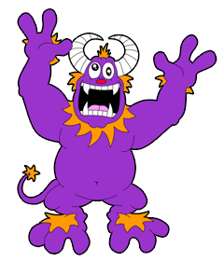
NAME __________________________________
HONORS BIO CREATURE FEATURES
Any physical or behavioral trait that helps an organism stay alive and reproduce in its environment is called an ADAPTATION. Adaptations allow one kind of organism to live where other kinds can’t. A cactus has adaptations that allow it to live in a dry, desert environment. A cactus has a thick, leathery stem that keeps the plant from losing too much water. A cactus would not do well living in the wet, subtropical Everglades. Polar bears have thick white fur to stay warm and blend in and fat layers to protect them from the extreme temperatures in the Arctic. Adaptations can also be behavioral. Song birds in South Dakota migrate south in the winter and hunting in packs helps lions capture and kill more food for the group.
Design a creature that is adapted to living in an environment of your choice. ANSWER THE FOLLOWING QUESTIONS about your creature and its habitat/niche then DRAW A PICTURE showing the ADAPTATIONS your creature has and the place it lives. Your description should include AT LEAST ONE BEHAVIORAL ADAPTATION!
What kind of habitat does your organism live in? (Include how cold it is, how much light & water are present)
( rocky, flat, grassy, woodland, forest, jungle, desert, water, cave, other planet, somewhere else?)

Where in the habitat does your organism fit in (NICHE)?
Is it a producer, herbivore, carnivore, omnivore, something else?

How is your organism adapted to moving around?

What does your organism eat and what adaptations does it have to help it gather food?

What adaptations does it have to help it defend itself against predators or avoid them?
How is it adapted to the temperatures it will encounter?

How will it reproduce? (Asexual, lay eggs, live babies)

WHAT ADAPTATIONS DOES YOUR ORGANISM HAVE AND HOW DO THESE HELP IT SURVIVE & REPRODUCE?
(You must have AT LEAST 6 adaptations ! One must be a behavioral adaptation)
 | ADAPTATIONS YOUR ORGANISM HAS | HOW DOES THIS HELP?
1
2
3
4
5
6
7
8

