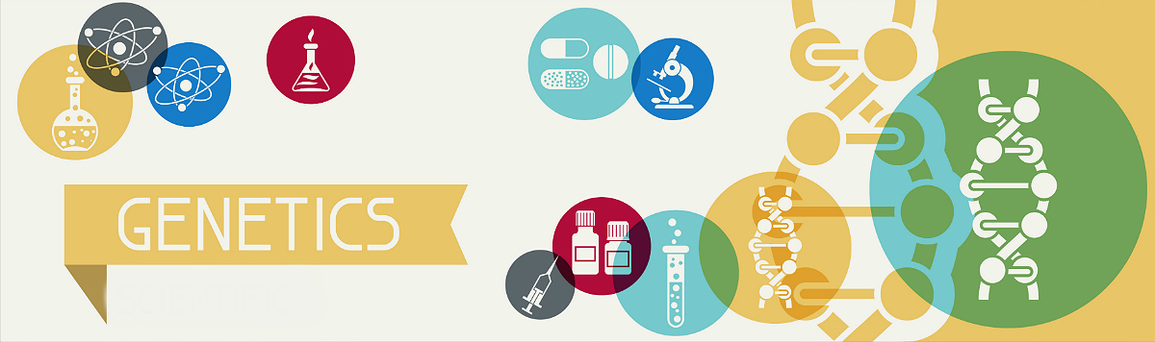
Genetics Research Project
The genetic disease I’m researching is .
The following people actively contributed in researching and writing this project:
First Name | Last Name | What sections did they work on?

Category | Guiding  Questions | Research  (Must be in paragraph form.) | Sources  (The site name AND the link)
Explanation of Genetic Disorder | → What are the symptoms of the genetic disorder?  → How is the disease viewed in one or more cultures?  → Who is most at risk for the disease?  → Include two pictures related to the disease.
Role of DNA | → What is the structure and function of DNA?  → explain how DNA causes this genetic disorder? Is there a specific mutation or extra gene that causes this disorder?  → Your research must include the words: DNA, DNA sequence, base pairs, chromosome, double helix, gene
Meiosis | → Summarize what happens in the process of meiosis.  → How does the creation of gametes (sex cells) lead to the genetic disorder?  → Your research must include the words: Meiosis, gametes/sex cells, chromosomes
Inheritance | → What is the probability that this genetic disorder is passed from parent to offspring?  → Use a Punnett square to explain the probability.  → Your research must include the words: Inheritance, heterozygous/carrier, homozygous, recessive, dominant, trait, allele, genotype, phenotype, carrier
Building Awareness | → What are ways in which society has bullied or caused harm to people with this genetic disorder?  → What can society do to provide support or resources to assist folks with this genetic disorder?  → What language should be used when addressing people with this genetic disorder?  What language should not be used?

Helpful Websites:
- Learn.Genetics Utah: http://learn.genetics.utah.edu/content/disorders/singlegene/
- Infotopia: http://www.infotopia.info
- The World Health Organization (WHO): http://www.who.int/en/
- Mayo Clinic: http://www.mayoclinic.org/
- Centers for Disease Control and Prevention (CDC): https://www.cdc.gov
Genetic Disorders *class copy please do not write on *
Genetically Inherited
Achondroplasia
Genetically Inherited Breast cancer
Cystic fibrosis
Down syndrome
Hemophilia A
Adult-Onset Huntington’s disease
Parkinson’s disease
Sickle cell disease
Tay-Sachs disease
Phenylketonuria
Color Blindness
Turner syndrome
Klinefelter syndrome
Androgen insensitivity syndrome
5-alpha reductase deficiency
Harlequin Ichthyosis
Fibrodysplasia ossificans progressiva
Fatal Familial Insomnia
Xeroderma pigmentosum
Treacher Collins syndrome
Polydactyly (Extra fingers or toes)

Rubric for Genetic Conditions Group Research (_46__ points)

 | 10 Points | 8 Points | 6 Points | 4 Points | 2 Points | 0 Points
Explanation of Genetic Disorder | Clearly and correctly answers all of the five questions from the research document - Explanation of Genetic Disorder Section. . | Clearly and correctly answers four of the five questions from the research document - Explanation of Genetic Disorder Section. | Clearly and correctly answers three of the five questions from the research document - Explanation of Genetic Disorder Section. | Clearly and correctly answers two of the five questions from the research document - Explanation of Genetic Disorder Section. | Clearly and correctly answers one of the five questions from the research document - Explanation of Genetic Disorder Section. | No explanation of genetic disorder.
Genetic Processes Leading to the Disease | Clearly and correctly answers both of the two section questions and includes all of the keywords. | Clearly and correctly answers both of the two section questions but is missing 2-3 of the keywords | Clearly and correctly answers both of the two section questions but is missing 4 or more keywords. | Clearly and correctly answers one of the two section questions and includes all of the keywords. | Clearly and correctly answers one of the two section questions but is missing keywords. | No explanation of genetic processes leading to the disease
Punnett Squares  OR  Meiosis sketches | All five punnett squares done correctly with percentage  Or  Meiosis sketch includes all relevant details of chromosome numbers | Four punnett squares done correctly with percentages | Three punnett squares done correctly with percentages  Or  Meiosis sketch is included but lacks detail (i.e. number of chromosomes) | Two punnett squares done correctly with percentages | One punnett square done correctly and percentage | No punnett square provided  Or  No meiosis sketch provided
Punnett Square explanations  Or  Meiosis Explanation | Correct and detailed explanation of the punnett squares or meiosis sketch with all the keywords | Correct and detailed explanation of the punnett squares or meiosis sketch with 2 keywords missing | Correct and detailed explanation of the punnett squares or meiosis sketch with 3 keywords missing | Correct and detailed explanation of the punnett squares or meiosis sketch with 4 keywords missing | Correct and clear explanation of the punnett squares or meiosis sketch, but no keywords used | No explanations provided for punnett squares or meiosis sketch
Building Awareness  → What are ways in which society has bullied or caused harm to people with this genetic disorder?  → What can society do to provide support or resources to assist folks with this genetic disorder?  → What language should be used when addressing people with this genetic disorder?  What language should not be used? | N/A | N/A | Detailed and correctly answers all questions | Detailed and correctly answers two questions | Detailed and correctly answers one question | No call to action.

Project Visual Rubric (40)
 | 10 points | 6 points | 4 points
Organization | - All the information is easy to read, see or hear.  - The topic is clear and visible.  - The information is in a logical sequence.  - The presentation is appropriate for the topic and audience.  - It contains written work, visual work , and verbal information. | - All the information is easy to read, see or hear.  - The topic is clear and visible.  - The information is in a logical sequence.  - The presentation is appropriate for the topic and audience.  - It contains written work, visual work , and verbal information. | - All the information is easy to read, see or hear.  - The topic is clear and visible.  - The information is in a logical sequence.  - The presentation is appropriate for the topic and audience.  - It contains written work, visual work , and verbal information
Content | - Scientific information is on topic and accurate.  - References appropriate language for people with the genetic disorder.  - Technical terms are well-defined in language appropriate for the target audience.  - There is an obvious conclusion summarizing the presentation.  - Explains all of the following:  - Who is at risk  - What are the symptoms  - How it is passed down  - References all of the following classroom content:  - Punnett squares  - DNA  - Meiosis  - Inheritance  - Chromosomes | - Scientific information is on topic and accurate.  - References appropriate language for people with the genetic disorder.  - Technical terms are well-defined in language appropriate for the target audience.  - There is an obvious conclusion summarizing the presentation.  - Explains all of the following:  - Who is at risk  - What are the symptoms  - How it is passed down  - References all of the following classroom content:  - Punnett squares  - DNA  - Meiosis  - Inheritance  - Chromosomes | - Scientific information is on topic and accurate.  - References appropriate language for people with the genetic disorder.  - Technical terms are well-defined in language appropriate for the target audience.  - There is an obvious conclusion summarizing the presentation.  - Explains all of the following:  - Who is at risk  - What are the symptoms  - How it is passed down  - References all of the following classroom content:  - Punnett squares  - DNA  - Meiosis  - Inheritance  - Chromosomes
Graphics | - Contains images of people with genetic disorder.  - Relevant graphic that explains the genetic disorders heredity and cause.  - Graphics have an explanation written and verbal.  - Graphics are clear and labeled.  - Two or more graphics explaining the genetic disorder are used. | - Contains images of people with genetic disorder.  - Relevant graphic that explains the genetic disorders heredity and cause.  - Graphics have an explanation written and verbal.  - Graphics are clear and labeled.  - Two or more graphics explaining the genetic disorder are used. | - Contains images of people with genetic disorder.  - Relevant graphic that explains the genetic disorders heredity and cause.  - Graphics have an explanation written and verbal.  - Graphics are clear and labeled.  - Two or more graphics explaining the genetic disorder are used.
Presentation | - The purpose of the presentation is visual and clear.  - Speakers maintains good eye contact with the audience and is appropriately animated (e.g., gestures, moving around, etc.).  - Speaker uses a clear, audible voice.  - Visual aids are well prepared, informative, effective, and not Distracting.  - Information was well communicated and all members participated. | - The purpose of the presentation is visual and clear.  - Speakers maintains good eye contact with the audience and is appropriately animated (e.g., gestures, moving around, etc.).  - Speaker uses a clear, audible voice.  - Visual aids are well prepared, informative, effective, and not Distracting.  - Information was well communicated and all members participated. | - The purpose of the presentation is visual and clear.  - Speakers maintains good eye contact with the audience and is appropriately animated (e.g., gestures, moving around, etc.).  - Speaker uses a clear, audible voice.  - Visual aids are well prepared, informative, effective, and not Distracting.  - Information was well communicated and all members participated.

