FOOD INC.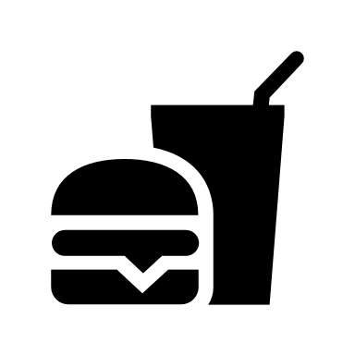
Below I have given you a list of controversial focus questions for the film. Please write your views on each topic with supporting evidence as well as the opposing view so you would be prepared to counter it. An important question to ask yourself when answering the following is: “What from the film supports that view?”
*NOTE: THERE OFTEN IS NO RIGHT OR WRONG ANSWER WITH THE VARYING AMOUNT OF PERSPECTIVES, VIEWS, EXPERIENCES, AND OPINIONS THAT WE AS A DIVERSE NATION BRING TO THE TABLE
Possible Focus Questions:
- Do animals have the right to a certain quality of life?

- Do people have the right to know what is in their food?

- Who is responsible for keeping our food safe?

- Should access to healthy food be a right for everyone?

- When deciding what to eat, how much should we consider the workers who pick, process, and transport it?

- Does it matter to you which food companies produce your food?

- Should companies be able to own the DNA contained in plant seeds?

- Should a company have the power to decide what information to give consumers about the food it produces?

- What individual or collective actions are you willing to take to improve our food system, and what would be their impact?

