Name: _______________________________________________ Date: _________________ Period: _______

**Classification Assessment: Study Guide**

SB3.c: Examine the evolutionary basis of modern classification systems

1. Describe Aristotle’s classification system. ________________________________________________________________________________________________________________________________________________________________________
2. List Linnaeus’ 7 taxonomic levels from largest to smallest (King Philip Came Over For Great Soup):
   1. ___________________________
   2. ___________________________
   3. ___________________________
   4. ___________________________
   5. ___________________________
   6. ___________________________
   7. ___________________________
3. What happens going down the levels of organization? Circle the correct response.
   1. Levels get larger/smaller
   2. Levels get less specific/more specific
   3. Organisms become less related/more related
4. If two organisms are found in the same order, what other levels of classification do they share? ________________________________________________________________________
5. Use the information below to answer the following questions:

Cougar Roach Paramecium

1. Animalia 1. Animalia 1. Protista
2. Chordata 2. Arthropoda 2. Ciliophora
3. Mammalia 3. Insecta 3. Ciliatea
4. Carnivora 4. Blattaria 4. Peniculida
5. Felidae 5. Blaberidae 5. Parameciidae

6. *Puma* 6. *Blaberus*  6. *Paramecia*

7. *concolor* 7. *craniifer* 7. *caudatum*

1. Which two organisms are most closely related? _______________________________________________
2. What class is paramecium in? ______________________________________________________________
3. What is the scientific name (binomial nomenclature) for the cougar? _______________________________
4. What is the scientific name for the roach? ____________________________________________________
5. What is the scientific name for the paramecium? ______________________________________________
6. What is the order for the roach? ____________________________________________________________
7. Has pointed ears .................................... go to 3

Has rounded ears ....................................go to 2

1. Has no tail ....................................... Kentuckyus

Has tail .................................................. Dakotus

1. Ears point upward ................................. go to 5

Ears point downward ..............go to 4

1. Engages in waving behavior ................... Dallus

Has hairy tufts on ears .................Californius

1. Engages in waving behavior ........... WalaWala

Doesn’t engage in waving behavior..... go to 6

1. Hair on head ................................ Beverlus

No hair on head (may have ear tufts).... go to 7

1. Has a tail ............................................. Yorkio

Has no tail, aggressive ............................ Rajus

1. Use the key above to determine the name of the organisms below:

  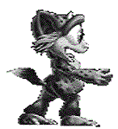

_____________________ _____________________ _____________________

1. What is a cladogram? _______________________________________________________________
   1. Organisms on a cladogram branch off from a common ___________________________.

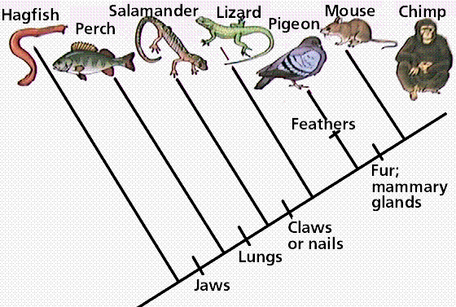

(Use this cladogram to answer 8-10)

1. Which of the following organisms are most closely related?
   1. Lizard and perch
   2. Lizard and pigeon
   3. Chimp and lizard
   4. Hagfish and pigeon
2. Which of the following organisms is the most primitive?
   1. Chimp
   2. Hagfish
   3. Perch
   4. Mouse
3. Which of the following characteristics do salamanders and pigeons share?
   1. Lungs and jaws
   2. Claws or nails
   3. Claws or nails and lungs
   4. Feathers
4. Complete the table below:

|  |  |  |  |
| --- | --- | --- | --- |
| **Kingdom** | **# of cells (unicellular/multicellular)** | **FOOD! (autotrophic/heterotrophic)** | **Moving? (Yes/Some/No)** |
|  |  |  |  |
|  |  |  |  |
|  |  |  |  |
|  |  |  |  |
|  |  |  |  |
|  |  |  |  |

1. What are two differences between eubacteria and archaebacteria? ____________________________________________________________________________________________________________________________________________________
2. Which kingdoms include organisms that have nuclei in their cells? ____________________________________________________________________________________________________________________________________________________

SB3.d: Compare and contrast viruses with living organisms

1. Explain why viruses are not considered to be living organisms. ______________________________________________________________________________________________________________________________________________________________________________________________________________________________
2. Why are viruses difficult to cure? ______________________________________________________________________________________________________________________________________________________________________________________________________________________________