Cell Organelles Name _____________________________________
Bozeman Science Video- http://www.bozemanscience.com/043-cellular-organelles

The Inner Life of a Cell link http://www.youtube.com/watch?v=wJyUtbn0O5Y

- The ______________________ is the control center of the cell. It tells other parts of the cell what to do.

- Working outward from the nucleus we have the ______________________ and _______________ endoplasmic reticulum.

- The rough ER is rough because it has __________________________ on it; and these are the site of _________________________ __________________________.

- The smooth ER is really responsible for making _______________________, and breaking down toxins.

- Proteins will be trapped in transport vesicles and brought to the __________________ complex. From there they can go to ______________________ parts of the cell or _____________________ the cell.

- The _________________________ is important in breaking down material when it is not used.

- The __________________________ is important in storage; particularly for plants.

- The two organelles that deal with ENERGY are the _________________________ and the _____________________________. (2:36)

- When you hear him talking about organelles, he is talking about ______________________ cells.

- All eukaryotic cells have __________________________, its how they make ATP.

- Producers (plant cells) are going to have _____________________________, and that’s so they can make sugar; which is then used by the mitochondria.

- Ribosomes are made up of two parts; ___________________ and ribosomal RNA and are synthesized (made) in the ___________________________.

- mRNA (messenger RNA) is made into a protein at the ribosome and this can take place in the _________________________ (free ribosomes) or at the rough ER.

- The __________________________ _________________________ is a membrane that folds upon itself that is located near or around the nucleus. It has ______________________ attached to part of it.

- The function of the Endoplasmic Reticulum is to give us a lattice, so it can ______________________ things.

- The __________________________ apparatus or complex takes things that are produced in the ER and ships them to different parts of cell. This would be the UPS of the factory.

- The ______________________ is the organelle that has a lot of digestive enzymes to break down materials such as viruses.

- The lysosome can also get rid of ____________________________ that’s not working or ____________ cells

- Because of this, the lysosome is sometimes referred to as the “_________________ sac”. They are really important in breaking down material that is not needed anymore. (6:49)

- The folding inside the mitochondria is called the ___________________ and its purpose is to increase surface area to make more ATP.

- The ______________________ in the cell is going to be mostly for storage. Every plant cell is going to a central or (large) ____________________ where they put water, some toxins, and pigments.

- And last is the __________________________, if we see a lot of these, that means we are doing photosynthesis.

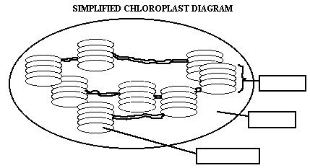
Thylakiod- membrane where photosynthesis takes place, contains green pigment chlorophyll.
Grana-stacks of thylakoids
Stroma- liquid filling in the chloroplast

